README: DEVELOPER EDITION

Intro
Hi new summer intern! Poor you will have to work with parts of my code… I’m a little sorry for how janky it might be. I focused a more on adding features than dealing with edge cases and errors. A lot of the files naming is very stringent, since my program specifically look for those string. My code is located in
/home/mziyan/Code/
the test data set that I used are in
/home/mziyan/TestData/
Unfortunately, there a very few data sets that are taken with prism, and the ones that do may be missing calibration files.
If you are trying to do single-order long stuff, I strongly recommend you trying to convince Glenn to do it in python… There is a IRAF library that may be of use.
You should also look at Sam Hedge’s readme, which will be in the documents section of my directory.
Any code that I modified (but did not originally write) will have zmo_ in front of it.
Feel free to email me at moziyan@yahoo.com and zmo@caltech.edu for questions. If I don’t respond, add me on facebook…(Ziyan Mo, at Caltech).

Running the program
NOTE:
------------------------
To run DataCubeManipulation.pro, you will need
- a folder named maps – Contain unformatted layers for the maps of the planet
- a folder named proc – Contains spectra reduced by Greg Farquhar’s pixel-by-pixel reduction code.
- a folder named spectra – Contains the raw, unreduced spectra
- a folder named formattedMaps – Contains the map layers after limbs have been fitted
- a folder named UMaps – Contains unformatted maps that have been updated (smoothed, corrected, etc)
- a folder named UFormatted – Contains formatted maps that have been updated (smoothed, corrected, etc)
- a folder named guideimg – Contains the processed guide images
- a folder named cal – Contains the calibration files.

IF ANY OF THESE FOLDERS ARE NAMED WRONG, SH*T WILL HIT THE FAN

Spextool itself onlt deals with prism grating type.
Single-order Long and single-Order short are not supported

Copy and paste the following to compile necessary files
.com /home/mziyan/Code/assignGeoCSV
.com /home/mziyan/Code/dataCubeManipulation
.com /home/mziyan/Code/getMu0
.com /home/mziyan/Code/getMuMu0
.com /home/mziyan/Code/getHeaderInfo
.com /home/mziyan/Code/nearest_element
.com /home/mziyan/Code/spexDriver
.com /home/mziyan/Code/viewingLayers
.com /home/mziyan/Code/writeMapHeader
.com /home/mziyan/Code/zmo_drm_ephemeris
.com /home/mziyan/Code/zmo_drm_lcm
.com /home/mziyan/Code/extsespec
.com /home/mziyan/Code/drm_cmap_sam
.com /home/mziyan/Code/zmo_pf_get_mu
.com /home/mziyan/Code/drm_xgeom
.com /home/mziyan/Code/zmo_pf_image_latlon
.com /prvt/glenn2/spitale/drm/programs/Spextool/pro/drm_spextool

-------------------------------
Step 1.

Open up spextools and DRM

Step 2.

Process each guide image. There will be a string of jup.00XXX.a images, and you should look at the image and the header in DRM to make sure the grating type matches the grating type of the spectra you will be reducing. See appendix 1.
Run assignGeoCSV for every processed guide image; put the

Step 3.

Update the paths to the respective directories

Step 4.

Create the Calibration files.

There should be 5 flats followed by an arc. If the files are
flat.00236, flat.00237, flat.00238, flat.00239, flat.00240,
arc.00241, enter in 236 - 241

Step 5.

Click on Spatial Extraction and reduce a single image. (See appendix 2 for more detailed steps)

Under images, if 240.a and 241.b exists, type in 240-241
For the full flat and wavecal name, find the calibrated file.
It should be named something like flat236-240, wavecal241-241
Now click on load Image

When everything is load, click on Guide image and find
the respective guide image.

Put the box on the slit; if the slit is too long vertically,
put it in the middle...

Exit out of the assign geometry window

Click Suggest/Flip Extraction Region

Click 'Go' under Make spatial profiles

Click the large horizontal button 'Extract'

Step 6.

Run createLayers

Input the respective directories and click 'Begin'

If everything goes well (fingers crossed), it will first reduce all the

Step 7.

Format the layers

Click the format button on the right hand side.

You will need to fit limbs several times; it would be total number of
layers divided by 100, rounded up no matter what.

YOU *****MUST***** fit the limbs for the very first (layer 0), and the
layer right before sum.fits. For more accurate limb fittings, you should
look through all the layers beforehand and figure out when the planet stops
/ starts moving (since for some odd reason the planet appears to shift...)

Once you're done fitting the limbs, click format again.

Step 8.

Run ViewingLayers again

Possible Errors
File not found:
Make sure the necessary files are compiled
Make sure the file exists
Check the line of code where it fails to see if you named something wrong

Index error:
Uhhhhh….. send me a screenshot if you can’t fix it…
Likely it’s because you had too many file and somehow matchingSpectraAndGuideImg didn’t process them all

Any other type of error:
Email me at zmo@caltech.edu and moziyan@yahoo.com. If I don’t respond in a few days, add me on Facebook (Ziyan Mo, studies at Caltech and has cover photos of artsy things)…

Features (buttons):
‘Get File’: can only open up sum.fits file. THEY MUST BE IN MAPS FOLDER
‘fit limbs’ : pop-up to fit the limbs so we can get accurate geometric data.
‘change layers’ : input a valid number and press this button to jump to a layer
‘auto-shift’ : supposed to automatically correct the image for you, but does not work at this time. (requires limbs to be fitted on that image)
‘shift manually’: pop-up to move lines of pixels; can shift horizontally or vertically; selected line of pixel are in green.
‘go to sum layer’: goes to the sum layer
‘smooth layer’: requires limb fitting on that layer; will get rid of horizontal striations.
‘format’: click it first, and it will ask user to fit limb 9 ascending images. When finished formatting, click again, and will fit limbs automatically, and output new files.
Details regarding the program
Lol I feel bad that you have to look at my code ( and possibly SpexTool/DRM’s code). Anyways, in this section I’ll be tracing through the code.

The first routine call is createLayers. This routine calls a few other routines to set up the widget environment (getOutputDirectory, getSpectrImage, getRawSpectrImage, getGuide, getCal). After user clicks on begin, create2D is called.
Create2D first checks for all of the paths being filled; you can manually fill-in the paths for debugging purposes. If the paths are not filled, we goto (spaghetti code sorry) the end of this routine. If all the paths are filled, we get rid of the widget, and get all the guide images. All the guide images should be processed at this point. We look call drm_cmap_sam on all the guide images to get their mu/mu0 values related to lat/lon. drm_cmap_sam will return a csv files with the guide image’s original name but ending with ‘.reftable’.
After the guide images have been processed, we start to reduce spectra by calling spexDriver. All code modified in spextool itself has a ;####### marker above and below the sections edited. New routines have the prefix zmo_ in front of it. spexDriver will first do some string manipulation to create name strings for the outputted matching spectra and guide image csv file. It will call getHeaderInfo, which will output two list of times in csv files, one for spectra and one for guide images. Next, findMatch is called. findMatch attempts to match up spectra and guide image times by converting both time into a string (by calling function stringToSec). I asked Glenn if the guide images were taken before or after each set of spectra; he didn’t really answer… So I went with each guide image is taken after each set of spectra. If the spectra A image is less than guide image time, then we put both A and B images with that guide image. If spectra A is more, advance the guide image counter, and put the spectra A and B with the new guide image. When everything is matched, the program will output a csv with a very obvious name in the current directory.
Now we are back in spexDriver; it loops through all raw spectra (incrementing by 2 due to A and B images). It calls various modified routines in spextools, and will output things in the proc folder. One thing that I neglected to do is changing the paths from inside spexDriver. You will have to manually change the paths in drm_spexTool.
We return to create2D, and we initialize all the arrays that we will need. There are some arrays that I never took out due to debugging purposes. We loop through every file. We get the lon/lat info from the header (Greg’s pixel-by-pixel reduction code, aka spatial extraction, stores it in the header.) We then try to figure out the numbering of spectra associated with each guide image. We then convert strings into floats (lon/lat parsed from header are strings for whatever reason). There was (is?) an error in which the lon/lat are far above what it should be… like in the 500-600 range. We attempt to correct it here, of course ignoring anything that actually may have caused in spexTool. We call getMuMu0, which is pretty much control-c, control-v from Sam Hedge’s code somewhere. We then add it to our arrays. The way to append arrays is pretty janky… it seems…
Now we call collapsingCube, and it’s time to talk about format of the reduced spectra. When Glenn first told me about data cubes, I was very confuzzled. Anyways, after the spatial extraction (pixel-by-pixel reduction) finishes, it outputs a 3D array. [Aperture, type, data]. Aperture is basically the location, ie, x. Type refers to the three possible data located: 0 is wavelength data, 1 is flux (the one we need), 2 is error, and the 3rd is not important (for me). You can check the format by *staring* at the jank file called extractspec_se.pro (path: /prvt/glenn2/spitale/drm/programs/Spextool/pro/backwardCompatibility/). We only need the flux, so we usually do datacube[*, 1, *]. For the summed flux, we weigh it against each wavelength, which is stores in datacube[*, 0, *]
Temparr has two dimensions, one for the line of flux, and one for the wavelength. We place those with the same wavelength next to each other. Sum array, on the other hand, only has the data for one (summed) line of flux.
Next, we rotate this final array; the first spectra should be on the very right, and goes right as more spectra are taken. It also has to be flipped horizontally. Finally, it outputs the file as map000.etc, map001.fits, etc… Only sum.fits has a header, which is made by calling writeMapHeader, though mapXXX files may have their header modified by viewingLayers. There is also a list of geometry outputted; this contains information for each point on the spectra, taken from the pixel-by-pixel reduction algorithm. It is very inaccurate and can be mostly disregarded.
Finally, we call viewingLayers with the path to the sum.fits file string as argument…
The other main program is viewingLayers.pro. I’m really sorry for how jank the code in this specific file is… ☹ viewingLayers will set up the widget. There is a long list of states, separated by data or widget. One thing to note is that the state.data.scale is set to 6, while later after formatting it will be hardcoded to 3. Perhaps a way to change the state.data.scale is nice. As you may know, the original map images are very small, so we need to blow it up for better visibility. From viewingLayers, we call loadFile followed by the image path. Loadfiles first reads in the current image. Next, using the information in the sum.fits header, it will get the path to the spectras (in the proc folder) and the path to the geometric list ( the CSV file with the lat/lon for each point for each layer.) We organize the geometric list by inserting a divider into the array; this divider is 10000+numbering of the spectra. Finally, we look to see if there is an updated version (ie, things in UMaps or formattedMaps). If they are updated, the original layer’s header has the path to the updated version. Finally, we set the sum.fits to be the current image, and get the image sizes. State.data.scale has not been applied.
We return to viewingLayer and call plotupdate, which will apply the scale to an image, and scaledImage is as the name implies. We also call updateInfoBar, which will give update layer, micron meter, x, y, etc etc in that row.
Set up is now complete, and user can interact with the program. The first thing they should do is click ‘fit limb’ button. This will call fitlimb. The functions related to the pop-up should be fairly easy. I will not go over most of them.
This will create a pop-up, and wait for user’s input. It will also set parameters to create an ellipse that touches the edges of the image. Lastly, it will call drawEllipse.
drawEllipse uses parametric formula, going by .5 steps every time. We increment in .5 to help us later when we have to deal with finding limb values for each x or y. You can also make the ellipse silent – it will calculate the limbarray, but will not draw it out. Otherwise, you will have an ellipse with a cross denoting the center.
I’m also going to talk about getscale. This is called automatically if this is the first time you are done fitting a limb, or when you click on reformat. To get the geometry correctly, we are actually transforming the ellipse into an another ellipse (which is very similar to a circle; eccentricity is very close to 0). We don’t know the exact axis for the transformed ellipse, which is why we have getscale. This will be at the edge of a planet in the only x and y axis. The edges are (centerX, highest/lowestY), and (highest/lowestX, centerY). Highest/lowest-> depending on whichever is in the viewable image. We are at the edge, and the scale goes from 0 to 500, testing if it is hitting the planet or not. Once we fail to hit planet, it means that the previous scale is the best fit. The x factor is typically around 50, and y scale is around 180. Once getscale finishes, the new factors should be outputted in terminal.
The function changeMapEvent is called when the user clicks on ‘change layers’. It just checks that the number are integers and are between 0 and state.data.numFIles-1.
The function called correctImage, called from clicking ‘Auto-Shift’. This program does not work correctly; it may or may not have been be looking at limbs with respect to the wrong axis… GL.
The function called manualCorrectImage is called when user clicks on ‘Shift manually’. This function does work lol. It first creates a temporary image that is 9 times larger, with the original image in the middle. This is done since the shifting would involve data loss, and making a large temporary image prevents losing data. Next, it creates a widget. Update selection is called to redraw the current highlighted box every time.
When shiftPixels is called, it first determines which button is pressed, and then literally transfer the data from one array cell to the other.
ShiftLayerControl, called by user pressing button ‘Shift Layer’, works the same way as above, except it moves the entire layer (and only this layer).
SmoothLayer, called by user pressing button ‘smooth layer’, works by first subtracting the sky (which is always at the edge of the picture). Next, we see categorize limbs in the ones on the left and the ones on the right. UpperlimbCoordX is on the right. We then have to organize it in ascending order to make sure nearest_element (F) works. We loop through every y to get the nearest Y there is on the limbs, and get the average value. This means that we now have a list of average values on the planet for each y. We loop through all the averages, and get the average of the four surrounding horizontal lines weighing the nearest two more. We get the current average minus the surround average. We divide that difference by number of pixels on the planet to normalize things. Finally, we apply the difference. We write things in the old header to denote that there is a new version, and the path to the old version in the header for the updated version of the map.
The most complicated and most iffy part of the program is formatLayers. It asks you to fit nine layer in ascending order, and records the averages to move each layer. THERE IS RESIDUAL CODE: the residual code attempts to fit layers based on the ratio between largest value and average value on the limb, which should be around 20%. That code is being excited but does nothing.
It will then save to formattedMaps the folder, and the image will be pretty large in the vertical direction.
You can also toggle between updates and older versions of the image by pressing ‘Old’ or ‘Updated’ on the second row, next to mu0.

(f) is for functions; otherwise it is a procedure

The sample format is

NameOfDocument:
- routineToStartEverything, arguments needed
: description
- supportingRoutine#1, arguments needed
: description
- supportingRoutine#2 (f), arguments needed
: description
etc etc

DataCubeManipulation:

- Zi, (none)
: Setting up the widget and starting the program

- getOutputDirectory, event
: Retrieving where the user wants the output
: path to be from button press

- getSpectrImage, event
: Retrieving the spectra directory path from
: button press

- getLatLon, event
: Retrieving the directory with guide image's
: longitude and latitude path

- resize, event
: Does nothing

- create2D, event
: Using the file paths from the inputs, we generate mu/mu0 data using
: Sam Hedge’s modified cmap code.
: Next, we call spexDriver, which will theoretically reduce all images
: in the spectra folder.
: Next, we look for all spectra files, and get the max size of
: apertures since they are not uniform.
: We then loop through all spectra, and get their lat/lon
: information from the header.
: We also get guideimage information, and we will keep
: track which images are associated with which guide images.
: This program assumes that reference guide image lat/lon
: information is already there; see drm_cmap_sam for his code.
: We match up lat/lon with emission angle and solar
: incidence angle (mu and mu0).
: We also match each guide with sets of spectra so it can be written into the header
: of the sum.fits file that will be outputted.
: Finally, we place the spectra side by side at all wavelengths.
: Finally, we output maps of each wavelength and the
: summed map, write the header, and call VIEWINGLAYER

- getMaxSize, file (list of spectra), numFiles, argument(which value to
look for), maxsize = maxsize (max of aperture),
wavemax = wavemax ( highest wavelength number)
: Since aperture number is uneven, get the largest number possible.

- collapsingCube (f), file (one single spectra), wavemax, temporaryArray, summedarry
: returns an array that gives flux values at
: each aperture. The flux value is the datacube[anynumber, 1, anynumber].

findgoodwave:
- findgoodwave, (none)
: Hard coded a path to see, in a file, where the
: numbers are not NAN

getHeaderInfo:
- getHeaderInfo, gfileType, guidePath, guideFiles, outputGuideFile,
sfileType, spectraPath, spectraFiles, outputSpectraFile,
outputPath
: It takes creates two csv files with the name of
: the file and the time that file was taken

getMuMu0:
- getMuMu0, lonArray, latArray, refPath, muArray = muArray,
mu0Array = mu0Array
: This procedure is called from dataCubeManipulation
: and it uses the geometry csv from the guide image
: to match lon/lat with the lon/lat from each point
: on spectra. After we get the index of the
: associated lon/lat, we can also get the emission
: angle and solar incidence angle ( mu and mu0)

findMatch:
- findMatch, guideRefPath, specRefPath, outputName, outputPath
: Attempts to find guide images and their respective spectra.
: It does this by reading the CSV files created by the
: other program, getHeaderTime.
: We convert the time into seconds, and compare the time in
: guide images to time in spectra.
: If the times do not match up at all, find the difference
: between the first spectra and the first guide image.
: Apply the difference to all of the spectra and attempt to match

- stringToSec (f), timesStr, modding = modding
: Returns the time in seconds, and if modding is true,
: this means that we passed through the 12 hour mark, and
: and we need to adjust for that

matchingwavelength:
- matchwavelength, (none)
: junk file.

printFits:
-printFits, (none)
: Hardcoded a path to save in a csv to see the values in
: a guide image file.

spexDriver:
-zmo, (none)
: Hardcode in spectra and guide image path; this routine calls
: getHeaderInfo and then findMatch. This generates a csv with
: a spectra name and its guide image.
: We then loop through every two spectra, and calls procedures
: from inside drm_xspextool to

writeMapHeader:
- writeMapHeader, outputpath (the file), geometryPath (path to list of
reference geometry list, spectraPath (directory containing
all the spectra), guideList (string array which each
element containing info about a guide image and the
associated spectra numberings), guideListCounter (Since we didn't
know the number of guides (shhh), we have a counter to keep track)
: Write the geometry list path, the spectra directory path, and
: all the guides and associated spectra numbering to a file.

Appendix

Appendix 1: (copied from Sam Hedge’s report)
  - Determining the appropriate guide image:
    - The guide images are usually taken just prior to the spectral image.
      - However, there were many instances when I could not easily associate each spectral image with its corresponding visible image. I used the .csv file generated from my script to try to figure these out. Supposedly the log book would also be useful, but I had a hard time deciphering it.
      - For each date, I made an excel file with what guide images I thought were associated with what spectral files. To do this, load the spectra into DRM, and after the calibration files are created, go to the Spatial Extraction mode tab. Load up the image normally, and click on Make Spatial Profiles tab. Note where the flux begins to approach background levels. You can change the y-range and consistently note where each spectra with a questionable guide image has the flux fall below a certain level.
        - Then open the potential guide images in DRM by pressing Get Files and selecting the potential guide images. Compare how much of the slit is on the planet in the guide image vs. where the flux drops to the background levels. THIS IS ONLY AN APPROXIMATION, THE TIMES ARE YOUR BEST INDICATION, but I have found it useful.
      - For some dates (July 20th, for instance) the nodding was not done in the typical way DRM is used to dealing with, so it may be best to use a single image for these rather than an AB pair. See images at Appendix for an example.
  - Preparing the guide image
    - From DRM, click on “Get Files”, and select the files you want to use to create the guide image, in AB order
      - Clicking on an image moves it to the selected images pane. Double clicking moves it to the pane and opens it. You can also select multiple images to the selection pane and then click “Browse->Browse All Selected” to view multiple images at once for comparing. Click on an image in the Selections pane to unselect it.
    - If doing an AB subtraction, select the images in AB order, and then click “Edit->Expressions”. In the DRM Expression Handler window that pops up, select “ABAB format subtraction”, and click “OK”. Then click on “Select>Select Updated” to select only the results of the ABAB subtraction. These are the A images of the pair. Unless you save them, they will not overwrite the old A image.
    - For each AB subtracted image:
      - Double click on the AB subtracted A image you prepared, in the Files box
      - Go to “Programs>Preprocessing>Image Tool File”. This uses information from the header file to help with the geometric association.
        - Click “Ok” to use the given values on the pop-up window behind the image.
        - Press Yes to add information to the header
        - Click “No” to not the sort file, as we do not need these images to go in the default DRM file structure
      - Then go to “Edit>Flip” to flip the image to the correct orientation.
      - Go to “Programs>Geometry>Fit Limb” to fit the limb
        - Use the up, down, left, and right arrow keys to adjust the limb. Use the Limb Bigger or Limb Smaller buttons to adjust the size of the limb.
        - To assist in the fitting, you can go to “Edit>Expression” and try typing in “a>0” or restrict the values of the pixel to a certain range, i.e. “100>a>10” or hist_equal(a). Be sure to go to “Edit>Undo” before you click on “Done” to undo the expression you entered.
      - Click on “Done-No Optimize”
Comment: The Optimize option has not been working right for me
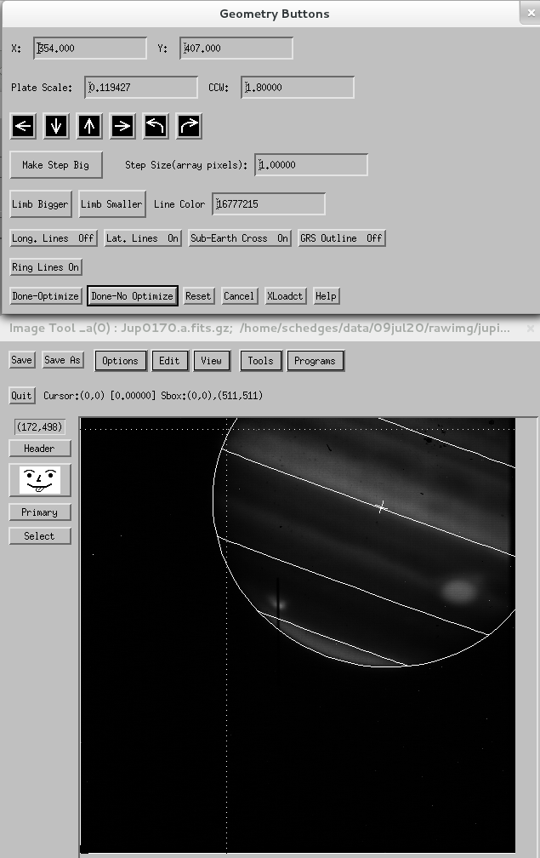

Figure 13. Assigning geometry to the guide image in DRM
      - Then go to “Programs>Photometry>Disk Aperture Photometry”, and click “Yes” to update the header file
        - A pop-up window will open behind the image
      - Go to “Save As”. The standard naming scheme I have been using is “jupguide#_#” for AB image pairs, and “jupguide#” for single A or B images. I have been saving the guide images in the cal folder
      - Click on “Quit” not the “x” in the corner to close, as this can freeze DRM. Your guide image is now ready for the Spatial Extraction routine.

Appendix 2: (copied from Sam Hedge’s report)
Comment: This routine was written by Greg Farquhar in 2013 to extract the spectra of extended sources on a pixel-by-pixel basis. This routine allows many more apertures than the default by the Spextool extended source option, and assigns the spectra to a geometric location on the planet based on a guide image associated with each spectrum. To learn more about preparing the guide images, see that section.
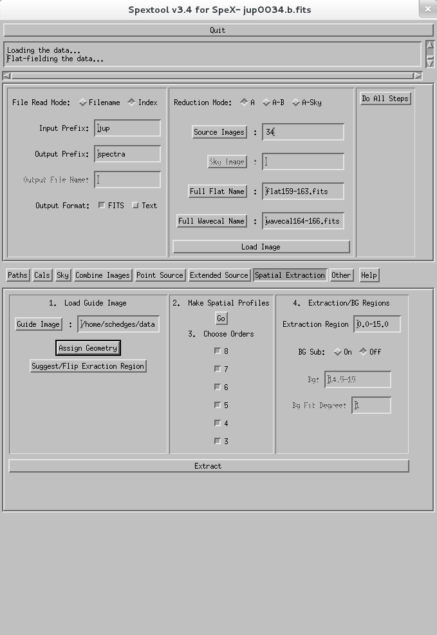

Figure 14. The Spatial Extraction base
  - Click on the “Spatial Extraction” tab to bring up the Spatial Extraction base
  - In the File Read Mode base:
    - Adjust the Input Prefix (typically “jup”) and Output Prefix (typically spectra).
  - The Load Image base:
    - For Reduction Mode choose either A, AB, or A-Sky mode.
    - For Source Image type in the numbers corresponding to the source images you want to use, i.e. for AB mode with files jup0001.a.fits and jup0002.b.fits make sure the prefix is “jup” and enter 1-2
      - You can also change the File Read Mode to Filename and then press the Source Images button and select the images that way
    - Press the Full Flat Name and Full Wavecal Name buttons to select the calibration files.
    - Click “Load Image”
      - DO NOT exit the window that pops up before the extraction is complete, doing so will cause Spextool to freeze later.
  - The Load Guide Image base:
    - Click on “Guide Image” and navigate to the location of the guide image you prepared
    - Click “Assign Geometry”
      - Click the pointer near the black rectangle on the guide image indicating the slit. Use the arrow keys for accurate tuning of the white box on the slit location
      - NOTE: I added code to Greg's routine to store the coordinates where the user saves the slit
      - Press “Done”
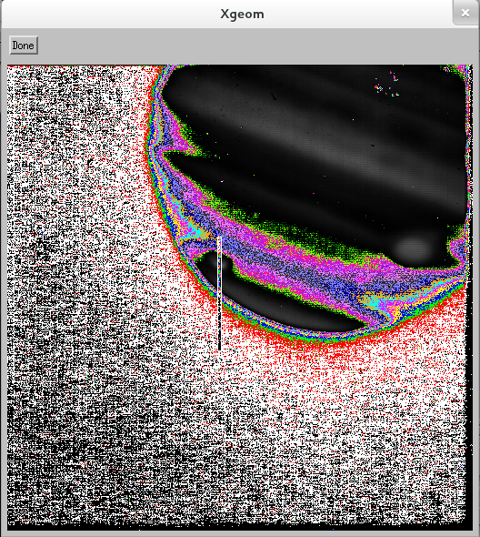

Figure 15. Assigning location to the slit with Spextool—the colors are not normally weird like this
    - Then click “Suggest/Flip Extraction Region”
  - The Make Spatial Profiles base:
    - Click “Go” in the Make Spatial Profiles base
      - DO NOT close this window, or you will get an error
  - Extraction/BG Regions base:
    - Check that the region in the spatial profile where the flux drops off (goes to the background level) is approximately the range in the “Extraction Region” box. If it is completely off, click on the “Suggest/Flip Extraction Region” button in the Load Guide Image base to switch the regions
      - DO NOT manually increase the extraction region, as you can extend it off of the planet, which will lead to a lot of errors layer on
    - If you see the background (i.e. an area where the slit becomes flat), turn BG Sub on and set the background region
      - Set the fit to 0 for a horizontal line (recommended)
  - Click “Extract” to extract the spectra
  - Press Done on the pop-up window.
  - If other spectra use the same guide image, you can now replace the Source Image text with the rest of the spectra using that guide image, and then press Do All Steps
    - Spectra that use the same guide image may be able to be combined using xcombspec. This is also a good way to check that all spectra truly used the same guide image. If one is significantly different than the others, it probably was taken at a different place and should use a different guide image.

IF ANY OF THESE FOLDERS ARE NAMED WRONG, SH*T WILL HIT THE FAN

